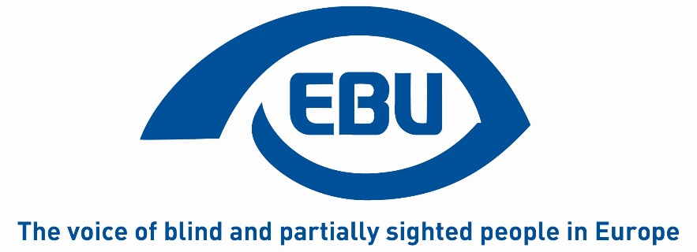

EBU Gender Equality Committee / Working Group Action Plan

Role of the Gender Equality Committee:
The role of the Gender Equality Committee was predetermined by three main objectives outlined in the text of the Malmo Declaration, adopted during the EBU GEAR Conference, held in Malmo, Sweden, on June 13-15, 2019. Based on those three main objectives, the members of the Committee propose, for the working period 2021 – 2023, the following actions:
Objective 1 - mainstream gender in all EBU work, policies and documents, including the constitution and by-laws:
- Review previous Constitutional amendments and adopted Resolutions and Make an overview of what is already in place for action and implementation of gender equality in EBU. Define what has already been implemented and what still needs to be done.
- If required, draft Constitutional amendments and Resolutions and present them to the Constitution and Resolutions Committees in time for the 12th EBU General Assembly to be held in 2023.
- Review EBU Policy papers that promote Gender Equality and revise or draft new ones if required.
Objective 2 - advance the work on balanced representation at all levels of EBU:
- To draft a Policy Paper with the aim to guide any incoming EBU Board on the practical implementation of the obligation and commitment to have balanced representation and leadership in all committees, commissions, working groups, project groups and EBU representation.
- At the second half of 2021 carry out a study, on the basis of a questionnaire and additional interviews, among blind and partially sighted women in EBU member countries in order to explore the reasons why in so many national organizations on local and regional levels women are represented on an balanced or at least almost balanced scale, while as soon as the national level or the international involvement comes into question, there is an extreme unbalanced situation. These study will be based on the examination of the 1999 and the 2019 EBU studies and the 2017 WBU study on balanced national leadership.
- In 2022, a year prior to the 12th EBU General Assembly, initiate a campaign among national members with the aim to stress the importance of balanced representation in the national delegations to the General Assembly and to increase the number of female nominations for the Board’s elections.
- Work closely with the EBU General Assembly Organising Committee to ensure that the Programme will represent diversity and balanced representation of gender, age, blind / partially sighted in moderators and speakers.
- Look into the possibility of organising a women´s forum in conjunction with the 12th EBU General Assembly to be held in 2023 (as called for in the Malmö declaration).
Objective 3 - raise awareness on the situation of visually impaired women and girls and work towards the inclusion of blind and partially sighted women in society and ensure that EBU’s work with the EU, EDF, EWL, ICEVI and other organisations takes into account the perspective and specific needs of visually impaired women of all ages:
- On the occasion of the 2021 International Women’s Day, prepare an article for the EBU newsletter introducing the Committee and its Action Plan.
- Look into the possibility to prepare a short video within the PARVIS framework. The video will aim to fight prejudice and disrespect by presenting facts about the differences between visually impaired men and women.
Membership of the Committee:
- Coordinator - Maria Kyriacou, EBU Secretary General
- Slovenia - Karolina Doltar
- Sweden - Annika Östling
- Spain - Barbara Martín Muñoz
- Germany - Martina Hellriegel
- Norway - Unn Ljøner Hagen
- EBU Board - Wolfgang Angermann
- Consultation – Birgitta Blokland

