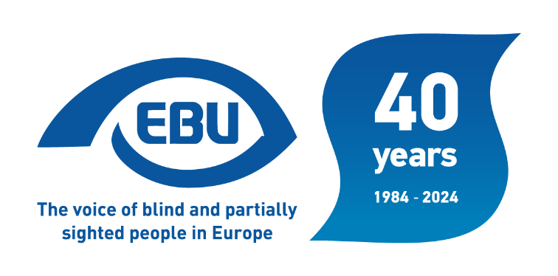

Welcome developments in the availability of disability statistics
EBU statement - January 2024

Introduction
Back in February 2019, in our Statement on the European Elections 2019, looking at the five years of EU legislature then ahead of us, we had raised the following concern among other:
“There are currently no reliable and comparable statistics at EU level on the inclusion of persons with disabilities, with disaggregated data per types of disability, a clear and consistent cut-off point to accurately class a person as disabled and consistent questions over time. This is particularly prejudicial, for instance, in addressing access to employment of blind and partially sighted persons: the dimension of the problem is largely hidden, as revealed by evidence gathered by EBU in some EU countries.
We ask the EU institutions, and in particular the European Parliament through its research service, to push for the collection and collation by Eurostat and national statistical offices of the necessary data to inform policy-making.”
We therefore saw it as a welcome development that the EU Strategy for the Rights of Persons with Disabilities 2021-2030, in which it defines European action to improve the lives of persons with disabilities, announced the following two actions under the heading “Awareness, Governance and Measuring Progress”:
- Action 62. “Develop, at the latest by 2023, new disability indicators with a clear roadmap for implementation. These should include indicators for children and the situation of persons with disabilities in employment, education, social protection, poverty and social exclusion, living conditions, health, use of new communication technologies, supporting the indicators for the EU Social Scoreboard, the European Semester Sustainable Development Goals.”
- Action 64. “Develop a strategy for data collection, steer Member States accordingly and provide an analysis of existing data sources and indicators including administrative data.”
Recently, as we are looking at the next European elections, we have been informed of Eurostat developments resulting from the Strategy that are of direct interest to us. After analysis, we would like to comment on these in this statement.

Moving away from medical approach
In the Eurostat list of statistical themes, Disability is now detached from Health. The data aim to assess whether persons with disabilities enjoy equal opportunities and full participation in all aspects of life, by allowing comparison with persons without disabilities.
The data cover the situation of persons with disabilities for various aspects of life, including income and living conditions, social protection, access to the labour market, access to education and training, access to health and care services, access to ICT, and leisure and social participation.
Another sign of moving away from the medical approach to disability is that the main measures of disability in all EU social sample surveys coordinated by Eurostat is the global activity limitation indicator (GALI) and other similar tools, such as the Washington group on disability statistics short set of questions on functioning.

Persistent limitations
Importantly, Eurostat acknowledges two current limitations, i.e.:
- That the data come mainly from population or household sample surveys that usually cover the adult population only and exclude people living in collective households and institutions, such as nursing or retirement homes, where usually many persons with disabilities live, especially the elderly; and
- That the periodicity of some surveys and statistics could be improved.
For our part, we continue to ask for data to be further disaggregated by type of disability, to reflect the specific situation of visually impaired people. To-date, the available data distinguishing by type of functional limitation is essentially just to quantify the respective types of limitations and their seriousness, whereas disability is generally treated as a whole when considering the different aspects of life.

Significant progress
Still, the recent developments, under the dynamic of the EU Disability Rights Strategy, are a welcome progress and response to a long-standing demand of EBU and the disability movement.
We would like to stress again here that an appropriate set of data on disability is paramount to informed policy-making and targeted measures.
We will now take the time to analyse the available data, to see what they tell us about the inclusion of visually impaired people and persons with disabilities in general. We will also look into the accessibility of the Eurostat database, as another matter of great importance to visually impaired people.
The European Blind Union (EBU) – Interest Representative Register number 42378755934-87 – is a non-governmental, non-profit making European organisation founded in 1984. It is one of the six regional bodies of the World Blind Union, and it promotes the interests of blind and partially sighted people in Europe. It currently operates within a network of 42 national members including organisations from 26 European Union member states, candidate countries and other countries in geographical Europe.
Contact: Antoine Fobe, Head of Advocacy and Campaigning
Email: ebucampaigning@euroblind.org - Tel: +33 1 88 61 06 64
www.euroblind.org
Twitter: @euroblind - Facebook: @EuropeanBlindUnionEBU

